# ICT394 Business Intelligence Application Development

## **Tutorial 05: Data Warehouse Implementation**

Background

This topic builds on the previous two topics in that it examines how the data warehouse would be created and the processes associated with its population through the Extract, Transform and Load (ETL) process.

The aim of this tutorial is to answer the following questions:

* What is the role of ETL in data warehouse design and implementation?

At the completion of this tutorial, you will be able to:

* Explain the role of ETL
* Understand dimensional modeling

#### Task 1: Dimensional Modelling Exercise

1. **Complete the following exercise** from the Jukic et al (2014) reading on pages 267/9. You can download Tutorial 5 Template on LMS.

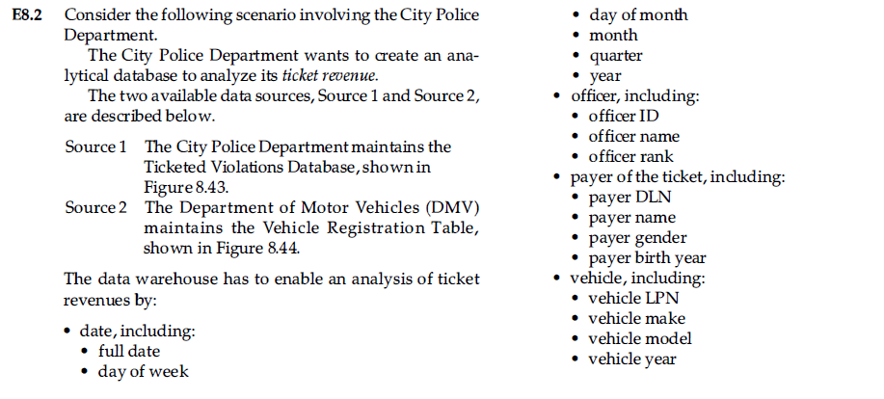

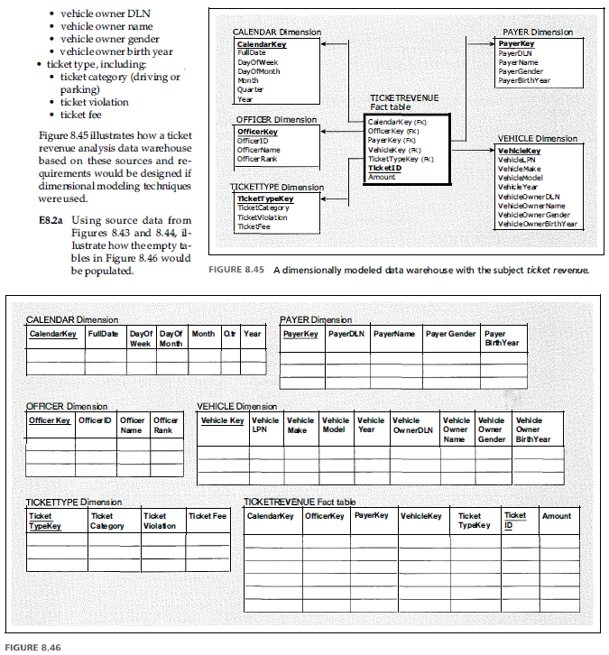

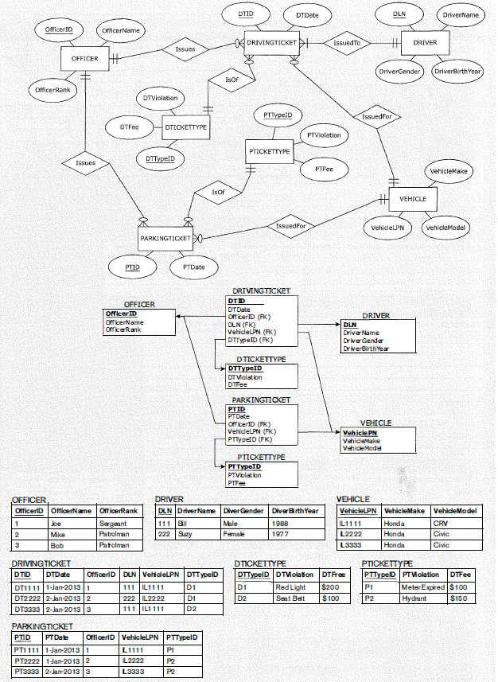

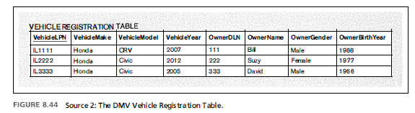

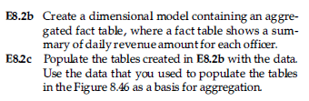

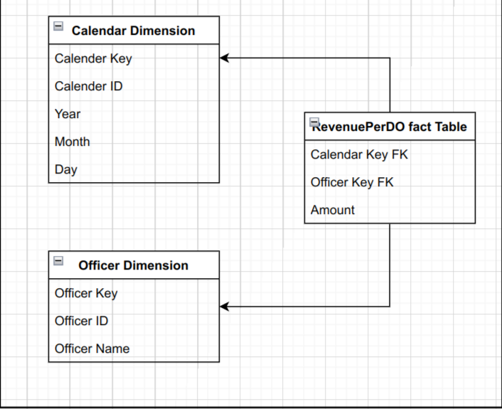

#### Task 2: Meson BI Feature Case Study

1. Watch the Meson BI Feature Case Study
   1. What challenges did Royal Liverpool Hospitals face with the previous platform?
   2. What benefits did Royal Liverpool Hospitals see that have accrued from the implementation of the Meson-BI platform and What role did the Cloud2 project team play in the implementation process?

#### Task 3: ETL Tutorial Questions

1. What are some of the main differences between the metadata you would expect in a relational database system, and the metadata you would expect for the data warehouse implementation?
2. Try and find some ETL tools that could help to automate the process of cleansing postal code data.